Troubleshooting Guide



**Troubleshoot Mailbox accessibility/connectivity/login issues**

Contents

1. Can’t send/Receive emails from Outlook 3

2. Email Service level change 4

3. OWA connection Issues 6

4. Unable to access Outlook due to Azure License Issue/Microsoft Software Licensing Issue 8

5. Office account issue after name change 8

6. Unable to access Webmail/outlook on personal machine 8

# Can’t send/Receive emails from Outlook

When users are unable to send/receive emails in outlook but OWA is working fine.

**Below could be the various scenarios to treat them**

Check the network/outlook connectivity issues.

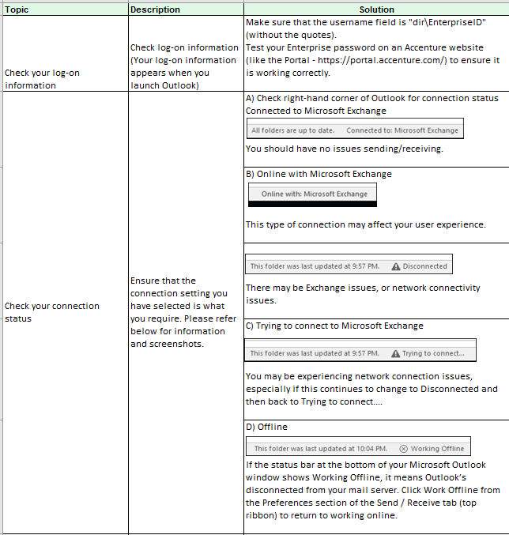

1. If the issue is related to network, please involve the local network team.
2. Have the user in addition tested on a different machine and network as well for issue persistence.
3. If the issue still persists, raise an incident with M&C team(SNOW queue MSGCOLLAB-O365-OPER) with the screenshots of the above steps.

# Email Service level change

Users with service level Y would **NOT** be able to access emails via Outlook. Only OWA would be enabled for them. If the users have no enough license, she/he might experience the following:

1. Unable to access Outlook
2. Unable to use Office applications such as Word, Excel etc.
3. Unable to access SharePoint or OneDrive

PFB few of the screenshots related to license issues.

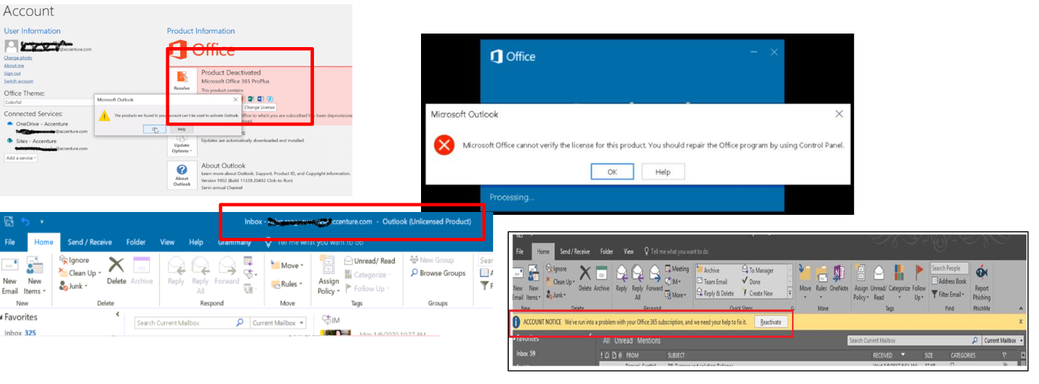

The user will need to submit a request in [Email Service Level](https://support.accenture.com/support_portal?id=acn_sac&sc_cat_id=37a5e6a2dba71bc02cfe7fc88c9619c3&spa=1&page=details) to change the current email service level. Further in case of issues submit a service now incident to IT Services **(SNOW Queue Name: APPSUP-APP-CIO-TechSvcs)** team to change the current email service level. If any issue arises during or after the change assign the ticket to IAM **(SNOW Queue Name:INFRADELV-IAM-DIR-OPER)** team for checking.

To check basic differences in profile refer [article](https://in.accenture.com/mycomputer/office-365-profiles-and-pricing-information/)

**Steps to check User Level Status**

1. Go to the below portal:

[https://directory.accenture.com/UserStatus/](https://directory.accenture.com/UserStatus/                                                                                                                                                                                             )

1. Enter the enterprise id of user

A screenshot of a cell phone

Description generated with very high confidence

1. Click on “Get Basic Information” as shown above to view the user status

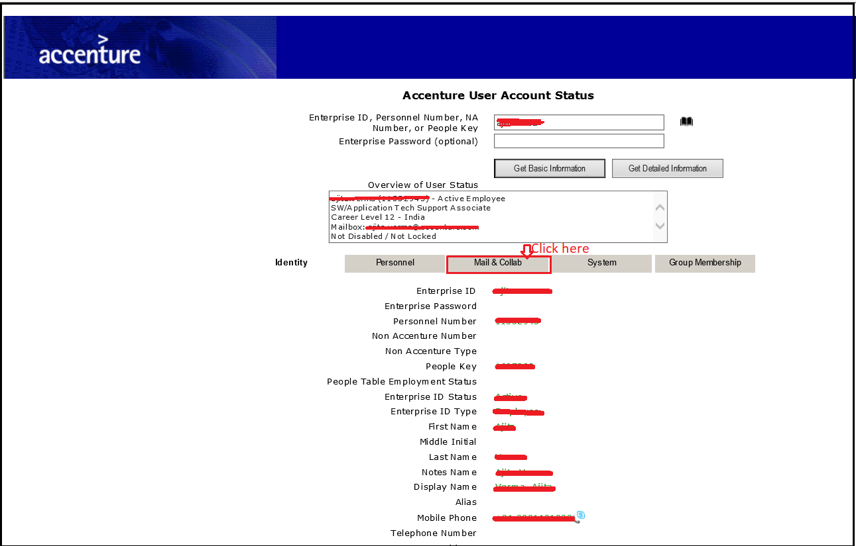

1. Click on “Mail &Collab” to get the user’s service level information
2. User service level is shown in “Email service Level”( eg. Z) field as shown below:

A screenshot of a cell phone

Description generated with very high confidence

*Note: To view the user’s detailed information, please click on “Get Detailed information” tab.*

# OWA connection Issues

When dealing with sync issues between Outlook and OWA it is important to make sure the user has direct access to his mailbox (OWA). Without access to OWA, Outlook will not connect as the application accesses the mail server to sync items.

**Troubleshooting**:

**1.** Make sure the user can access to OWA from his location

Have the user login to [https://myemail.accenture.com/”EID”@accenture.com](https://myemail.accenture.com/)

**2.** If the user has no access to OWA, the error message will determine next steps.

**3.** The error message is browser based (404, 403, connection reset, license expired, etc.)

A browser error message indicates the user cannot reach the mail server from his location. This is not an Exchange/O365 issue but a Network one as the user is simply unable to reach the service. Reach out to the user’s local Networking Team if connecting from an Accenture location, the client’s Network Team if connecting from a client site or his ISP’s Tech Support if connecting from Home.

**Sample Browser Error:**

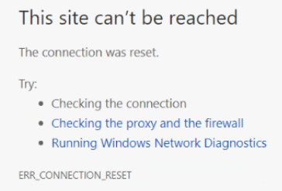

**4.** The error message is O365/Exchange Based

An O365/Exchange error message indicates a problem with either the Mailbox or the Service. Errors that deal with **Licenses** and the “Sorry, we can’t get that information right now…” error message are handled by **IAM(**INFRADELV-IAM-IGA-OPER**)** team and should be sent to their queue as a first point of escalation. Escalate any other O365/Exchange error message to **M&C(**MSGCOLLAB-O365-OPER**)**

**Sample O365/Exchange errors:**

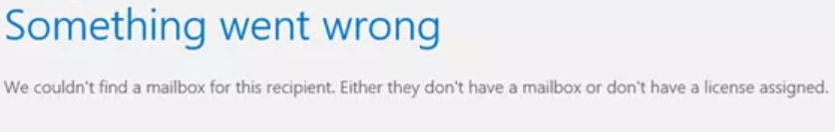

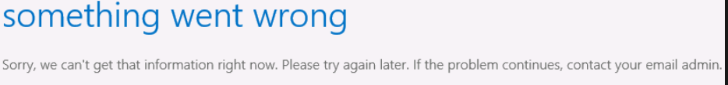

# Unable to access Outlook due to Azure License Issue/Microsoft Software Licensing Issue

Outlook is unable to connect and OWA is inaccessible.

1. User is unable to access email via Outlook
2. OWA is throwing an error mailbox license is expired such as below:

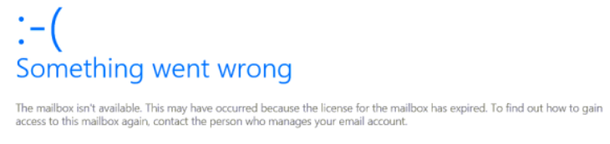

Forward the incidents to IAM team **(Queue Name: INFRADELV-IAM-IGA-OPER)**

# Office account issue after name change

1. Users are unable to configure new Outlook account.
2. Users’ Outlook is not loading new emails or not connecting.
3. Users are unable to log in to other Office applications.

Once the name is changed, it takes around 10-15 days to replicate changes the whole environment. Affected user may use OWA( <https://myemail.accenture.com> ) as a work around. If the issue persists, try to create a new outlook profile. User may reach out to IAM (**INFRADELV-IAM-IGA-OPER**) team if the new outlook profile does not work to reset the Azure licenses of affected users.

# Unable to access Webmail/outlook on personal machine

**Unable to access webmail on personal machine**

User unable to access Accenture webmail (OWA) on personal machine. Please follow bellow steps to diagnose the issue.

1. Check URL of OWA which user using to access, it should be <https://myemail.accenture.com>
2. Check if OWA is enabled for that mailbox using **User status** site under **Mail & Collab** Tab ( <https://directory.accenture.com/UserStatus/> )

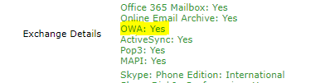

**Note**- if OWA disabled please assign incident to IAM team (**INFRADELV-IAM-IGA-OPER**) to get this checked and enabled

1. Please ask user to do Telnet from his personal system using command Prompt (CMD):
2. Type windows+R
3. Type telnet, If the below error is obtained

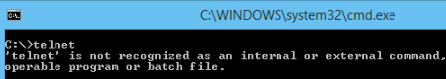

1. Follow the steps below to enable the telnet client through command line
2. Run the below command in command prompt with administrator permissions.

**dism /online /Enable-Feature /FeatureName:TelnetClient**

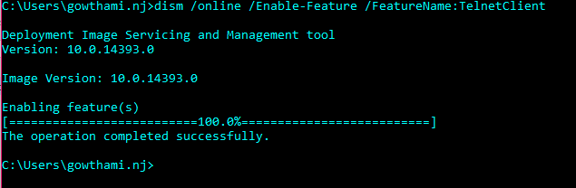

That’s it, after a few seconds telnet should be ready to use.

Type **Telnet myemail.accenture.com 443** and hit enter Key

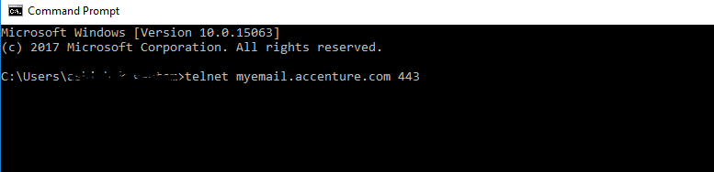

Result should be as below:

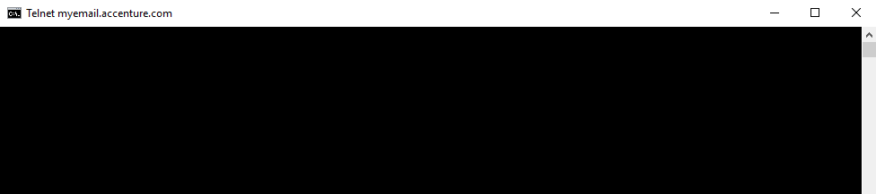

**Note**- If result is blank screen, that means there is no connection issue and all required ports are opened.

1. Please ask user to try to access Accenture webmail in other system as well as in Accenture network with Accenture managed PC/Laptop. If webmail worked fine in other system or Accenture managed PC/Laptop then it’s local client issue, ask user to check with his local network vendor. No action required from M&C side.

**Unable to access outlook on personal machine**

A new conditional access policy is applied to all users so that only Accenture Managed PCs will be allowed to connect to Exchange via Outlook. This means that any user running on a client owned or personal computer will only be able to access his Accenture email via OWA. The policy will be applied on Azure AD and will not affect Macs nor Mobile devices (which are already secured with Intune).

From now on, if you need to check if a user has been deployed already, you need to check if he is a member of group MA_OutlookDeployment from the[link](https://directory.accenture.com/WebAdmin/search.aspx)or access[userstatus](https://directory.accenture.com/UserStatus/)and check under the group membership tab.